MASCHERPA Audric ROB 3 2022 / 2023

**POLY-SNAKE**

**Weekly report n°17 from 19/03/23 :**

This session being shorter than the others, my partner and I decided to dedicate it to the search for a bug present on the movement of the polySnake. Indeed after the few tests carried out at the previous session it turned out that a servomotor did not work as we wanted.

This servomotor does not respect the instruction of the movement that we imposed on it with our program in figure 17.1.

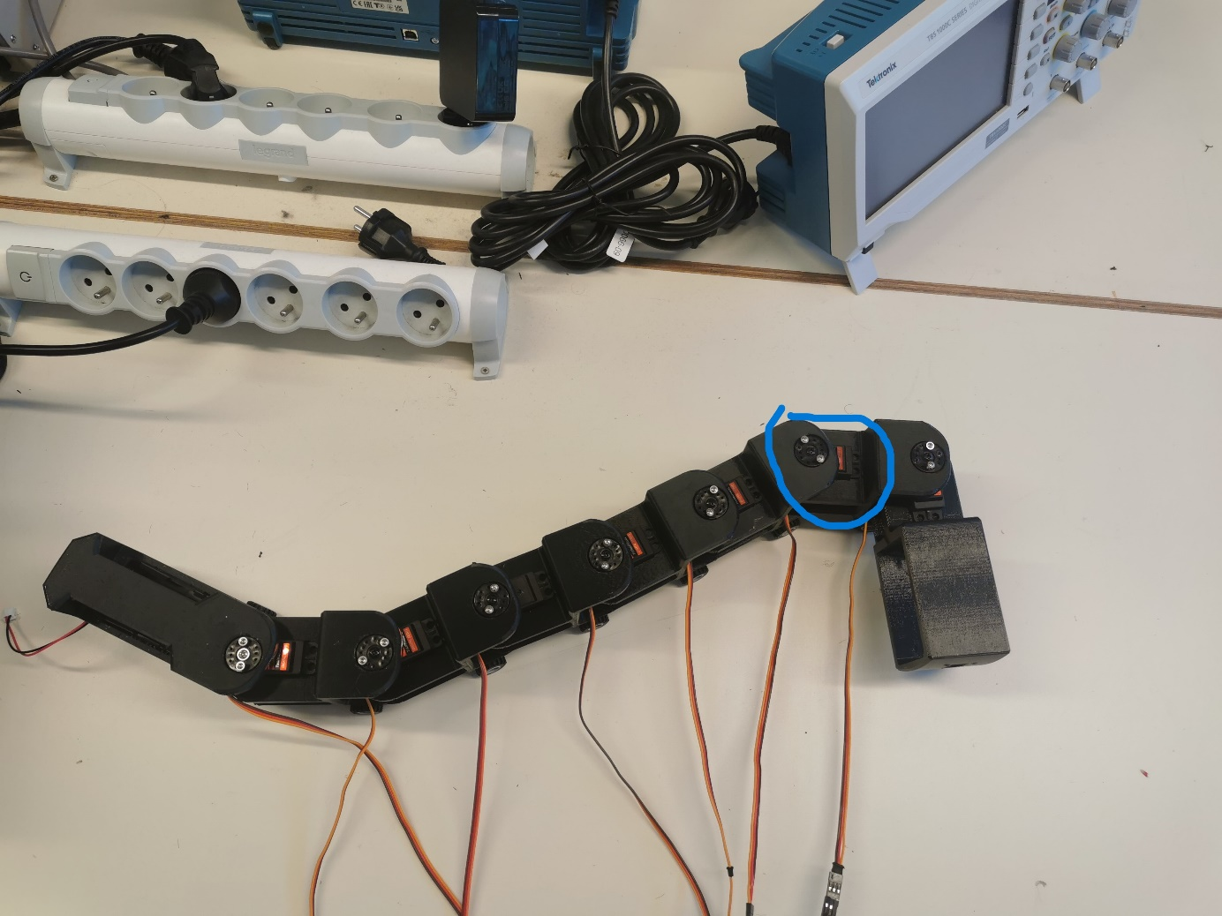

Figure 17.1

Figure 17.2

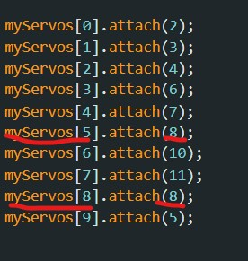

After doing some research, it turned out that the problem did not come from the cables, nor from the Arduino card, nor from the servomotor itself, but it was a nice program that assignat two different instructions on a ping, which bugged the servo motor connected to this ping as shown in figure 17.2.

So after solving this problem we were finally able to perform the movement test on PolySnake but this time with all the body of our snake composed of 7 modules and the tail / head

Here is a link to the youtube video showing the movement of the snake using all these modules imprinted with the PETG filament :

<https://www.youtube.com/watch?v=nyOi0dM7rbw>